TC-CUS-001
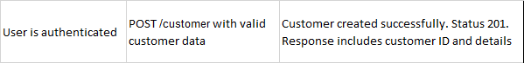
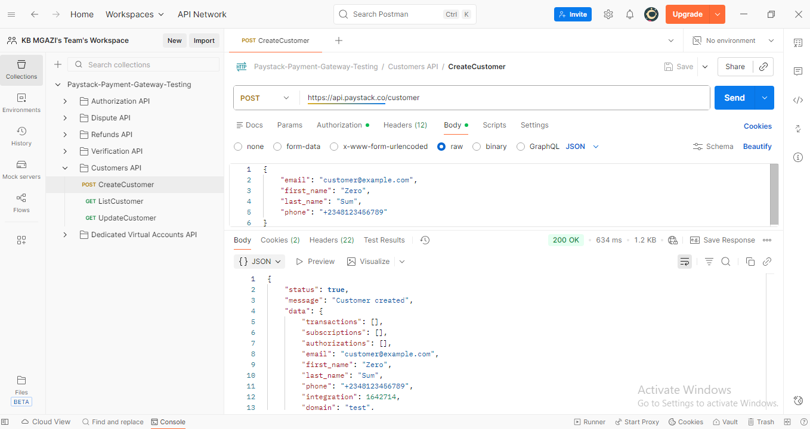
Request:
{
"email": "customer@example.com",
"first_name": "Zero",
"last_name": "Sum",
"phone": "+2348123456789"
}

Response:
{
"status": true,
"message": "Customer created",
"data": {
"transactions": [],
"subscriptions": [],
"authorizations": [],
"email": "customer@example.com",
"first_name": "Zero",
"last_name": "Sum",
"phone": "+2348123456789",
"integration": 1642714,
"domain": "test",
"metadata": {},
"customer_code": "CUS_vs0obameewnf6jv",
"risk_action": "default",
"id": 320161482,
"createdAt": "2025-11-19T16:15:09.448Z",
"updatedAt": "2025-11-19T16:15:09.448Z",
"identified": false,
"identifications": null
}
}

